Department of Education
Schools Division Office 1 Pangasinan
PRIMEHR Human Resource Management System
User Manual
Admin Role

Generated on May 08, 2026

Table of Contents
Table of Contents
System Overview
Step 1: Login Page
Instructions
Step 2: My Submission
Instructions
Step 3: Admin Dashboard
Instructions
Step 4: User List
Instructions
Step 5: 201 File Validation
Instructions
Step 6: Leave Management
Instructions
Step 7: Performance Forms
Instructions

System Overview
This manual guides the Admin through the main PRIMEHR procedures. Screenshots are loaded automatically from the role screenshot folder and inserted beside the matching step.
Screenshot folder: manual_images/admin/

Step 1: Login Page
Page title: Login Page
This page allows authorized users to access PRIMEHR using their registered account.
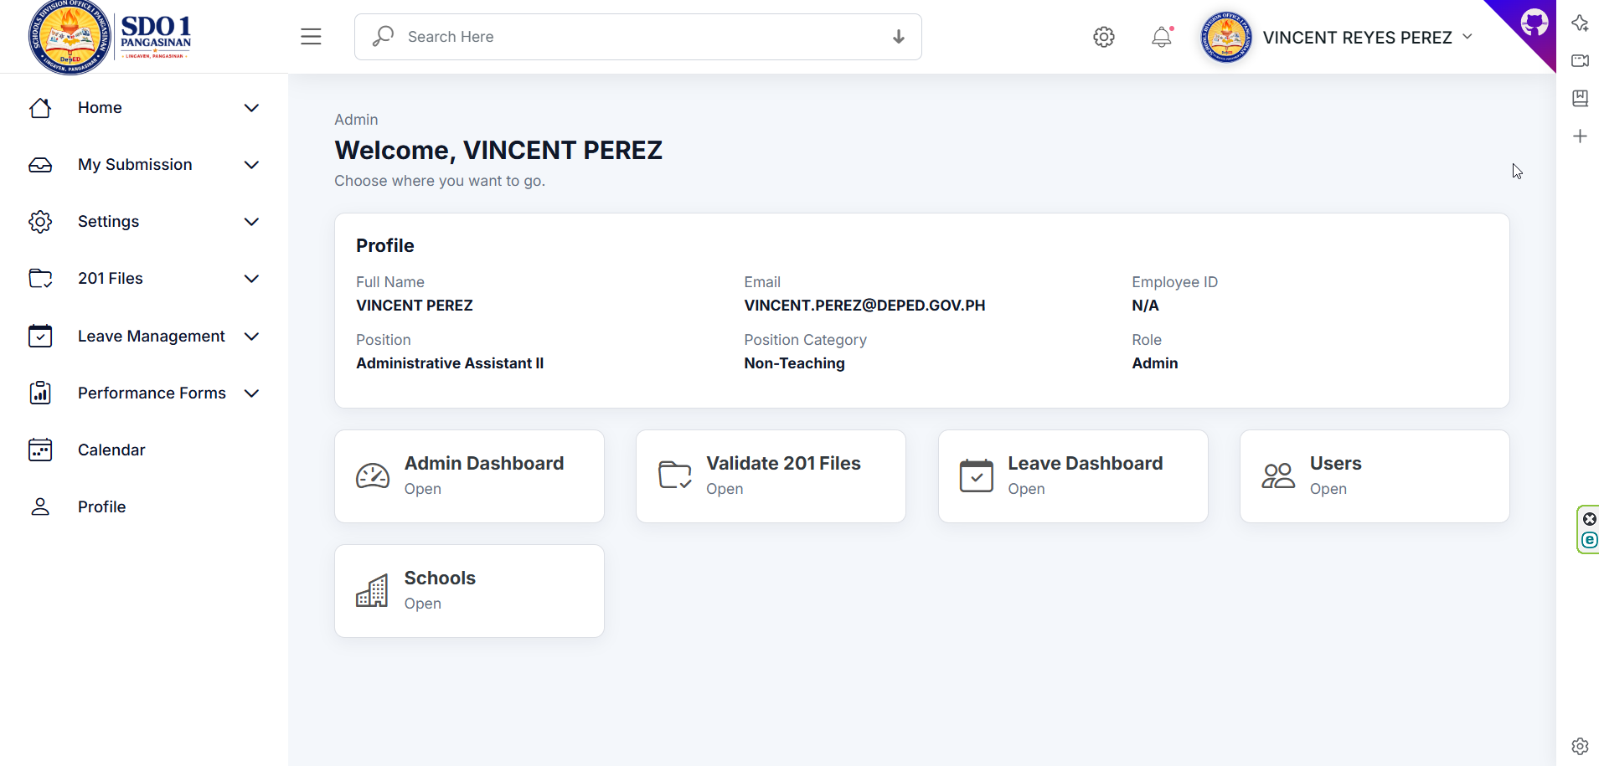
Figure 1. Login Page Page

Instructions
- Open the PRIMEHR login page in your browser.
- Enter your username and password.
- Click Login to continue to your dashboard.
Important notes
- Do not share your account credentials with another employee.

Step 2: My Submission
Page title: My Submission
This menu contains employee-required submissions such as 201 files, leave credits, OPCRF, and IPCRF.
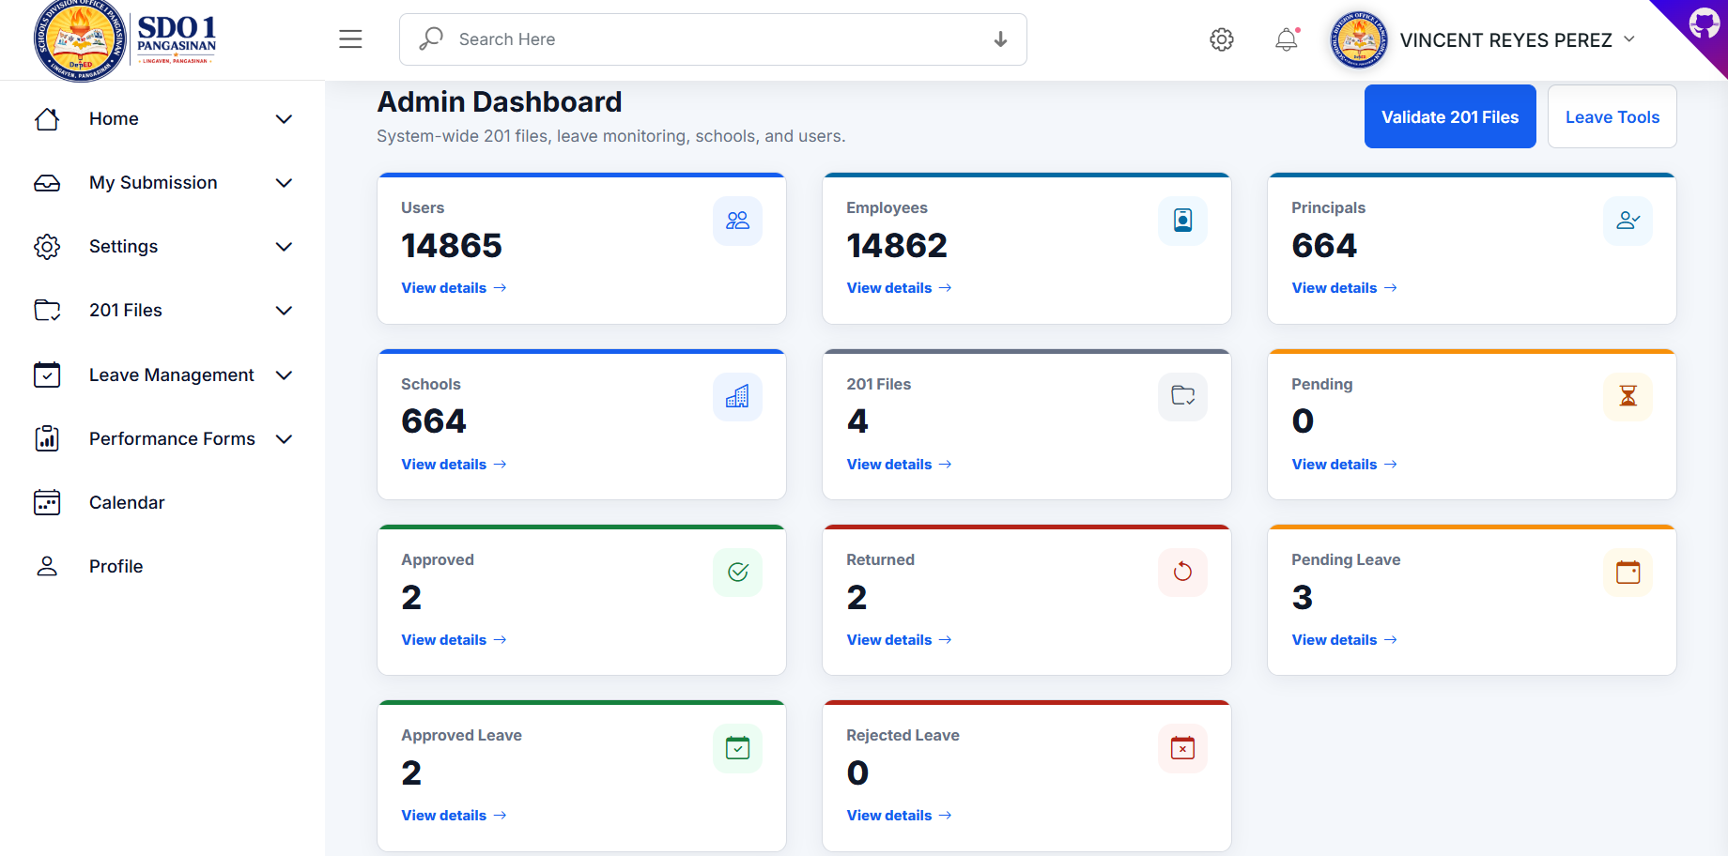
Figure 2. My Submission Page

Instructions
- Open the My Submission menu from the sidebar.
- Select the module you need to open.
- Review the page before adding or updating records.
Important notes
- All users, including admin accounts, should maintain their own required submissions.

Step 3: Admin Dashboard
Page title: Admin Dashboard
The dashboard shows system-wide summaries for users, schools, 201 files, and leave activities.
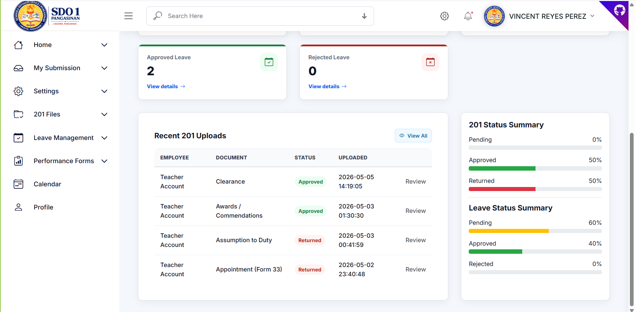
Figure 3. Admin Dashboard Page

Instructions
- Go to Home, then click Dashboard.
- Review the summary cards and recent activity tables.
- Use the sidebar to open the module you need to manage.
Important notes
- Dashboard counts depend on the records currently saved in the database.

Step 4: User List
Page title: User List
The user list is used to add, update, filter, and manage employee accounts and roles.
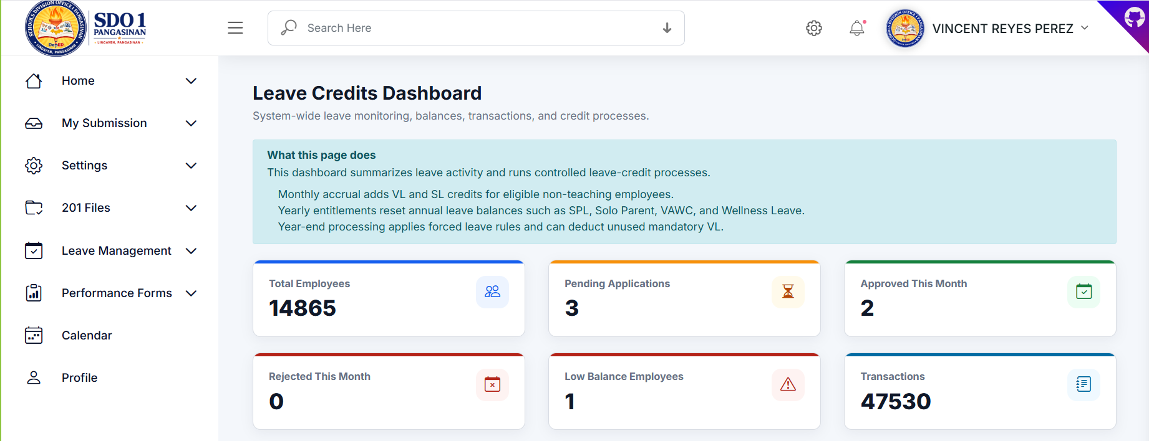
Figure 4. User List Page

Instructions
- Open Settings, then click User List.
- Use the filters to find users by personnel type, school, division unit, or office unit.
- Click Add to create a user or Update to edit an existing account.
Important notes
- Assign the correct role, division unit, office unit, and validator tasks to avoid access issues.

Step 5: 201 File Validation
Page title: 201 File Validation
This page is used to review uploaded 201 file documents and mark them as approved or returned.
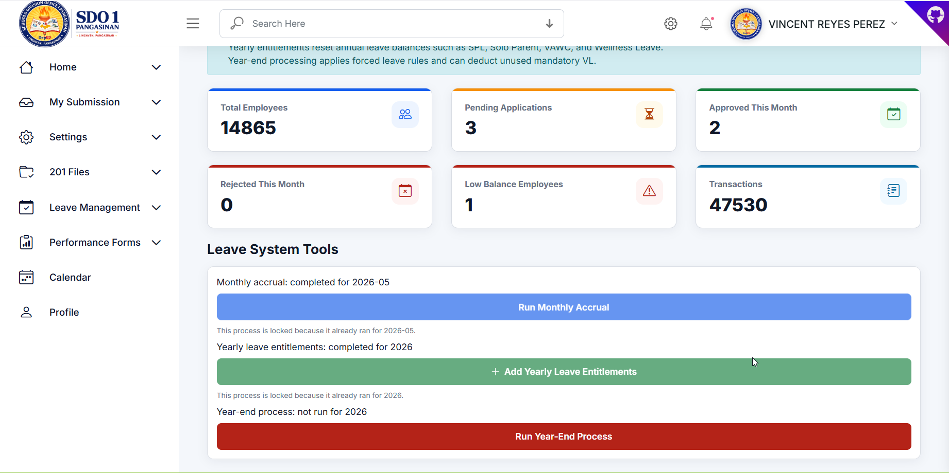
Figure 5. 201 File Validation Page

Instructions
- Open 201 Files, then click Validate 201 Files.
- View the uploaded document.
- Approve the file if correct, or return it with remarks if correction is needed.
Important notes
- Always provide clear remarks when returning a document.

Step 6: Leave Management
Page title: Leave Management
The leave module handles leave applications, balances, ledgers, transactions, and reports.
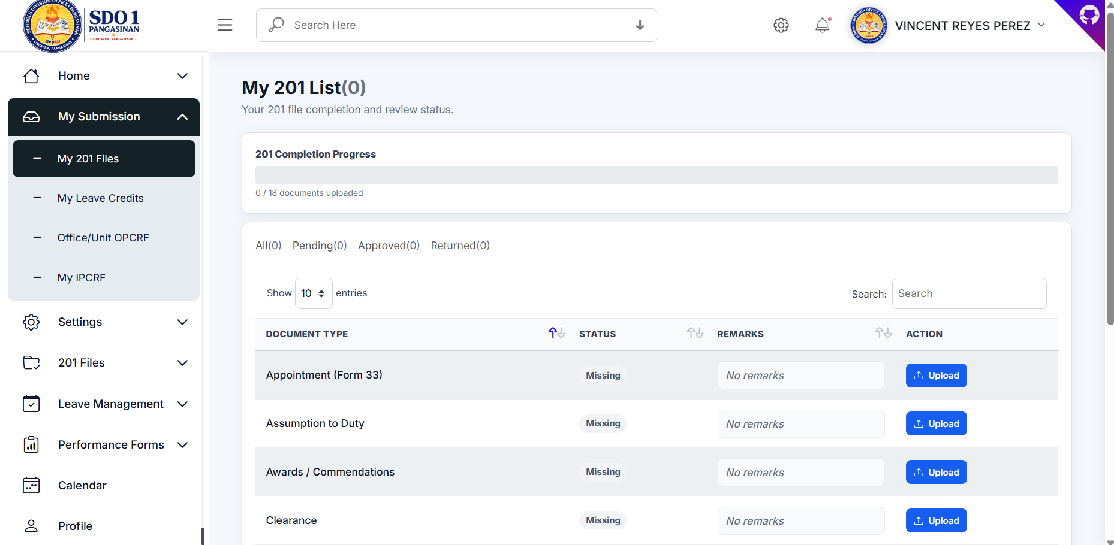
Figure 6. Leave Management Page

Instructions
- Open Leave Management from the sidebar.
- Choose Leave Applications, Leave Balances, Ledger, or Transactions.
- Review records carefully before approving or rejecting requests.
Important notes
- Leave balances and ledgers are affected by approved applications and credit processes.

Step 7: Performance Forms
Page title: Performance Forms
This module manages Office/Unit OPCRF and employee IPCRF submissions.
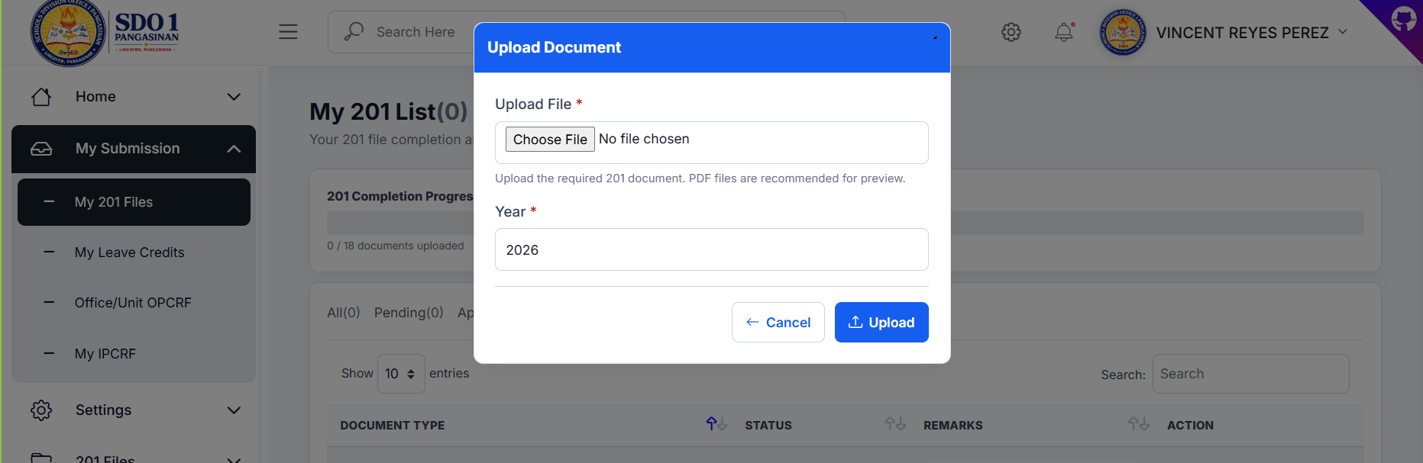
Figure 7. Performance Forms Page

Instructions
- Open Performance Forms from the sidebar.
- Select Office/Unit OPCRF, Employee IPCRF, or Offices / Units.
- Validate submissions or assign office/unit heads as needed.
Important notes
- Office Head is used for higher-level signing, while Unit Head is used for OPCRF submission.

